

**Semester Two**

**Examination 2017**

**Question/Answer booklet**

**MATHEMATICS**

**METHODS UNIT 1 and 2**

**Section Two:**

**Calculator-assumed**

|  |
| --- |
| Student Name: _____________________________________ |
| Teacher’s Name: _____________________________________ |

**Time allowed for this section**

Reading time before commencing work: ten minutes

Working time for paper: one hundred minutes

**Material required/recommended for this section**

**To be provided by the supervisor**

This Question/Answer booklet

Formula Sheet (retained from Section One)

**To be provided by the candidate**

Standard items: pens (blue/black preferred), pencils (including coloured), sharpener, correction tape/fluid, erasers, ruler, highlighters

Special Items: drawing instruments, templates, notes on two unfolded sheets of A4 paper, and up to three calculators approved for use in the WACE examinations.

**Important note to candidates**

No other items may be taken into the examination room. It is **your** responsibility to ensure that you do not have any unauthorised notes or other items of a non-personal nature in the examination room. If you have any unauthorised material with you, hand it to the supervisor **before** reading any further.

**Structure of this paper**

|  |  |  |  |  |  |
| --- | --- | --- | --- | --- | --- |
|  | Number of questions available | Number of questions to be attempted | Working time (minutes) | Marks available | Percentage of exam |
| **Section One**  **Calculator—free** | **9** | **9** | **50** | **50** | **35** |
| Section Two  Calculator—assumed | 14 | 14 | 100 | 100 | 65 |
|  | | | |  | 100 |

**Instructions to candidates**

1. The rules for the conduct of Western Australian external examinations are detailed in the

*Year 12 Information Handbook 2017.* Sitting this examination implies that you agree to abide by these rules.

1. Answer the questions according to the following instructions.

**Show all your working clearly.** Your working should be in sufficient detail to allow your

answers to be checked readily and for marks to be awarded for reasoning. Incorrect answers given without supporting reasoning cannot be allocated any marks. For any question or part question worth more than two marks, valid working or justification is required to receive full marks. If you repeat an answer to any question, ensure that you cancel the answer you do not wish to have marked.

It is recommended that you **do not use pencil**, except in diagrams.

1. You must be careful to confine your responses to the specific questions asked and to follow any instructions that are specific to a particular question.
2. Spare pages are included at the end of this booklet. They can be used for planning your responses and/or as additional space if required to continue an answer.

* Planning: If you use the spare pages for planning, indicate this clearly at the top of the page.
* Continuing an answer: If you need to use the space to continue an answer, indicate in the original answer space where the answer is continued, i.e. give the page number. Fill in the number of the question that you are continuing to answer at the top of the page.

1. The Formula Sheet is **not** handed in with your Question/Answer Booklet.

# Section Two: Calculator–assumed 65% (100 marks)

This section has **fourteen (14)** questions. Attempt **all** questions. Write your answers in the spaces

provided.

Spare pages are included at the end of this booklet. They can be used for planning your responses

and/or as additional space if required to continue an answer.

* Planning: If you use the spare pages for planning, indicate this clearly at the top of the page.
* Continuing an answer: If you need to use the space to continue an answer, indicate in the original answer space where the answer is continued, i.e. give the page number. Fill in the number of the question(s) that you are continuing to answer at the top of the page.

Working time: 100 minutes

**Question 10 (5 marks)**

In the triangle PQR given below, PR = *x* units, PQ = 2*x* units and RQ = 3 units.

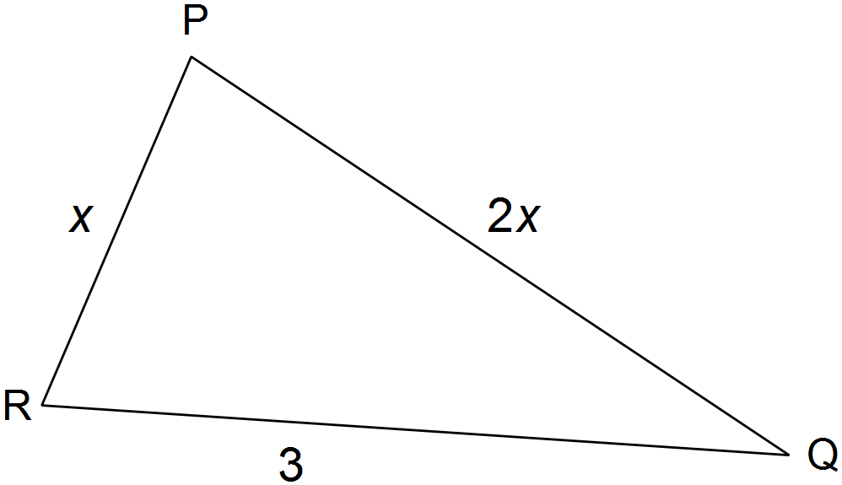

**(a)** Show that 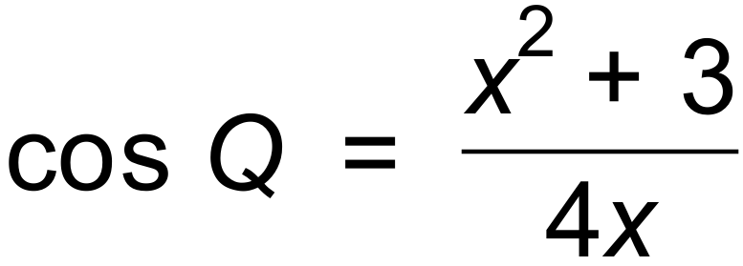 (2 marks)

**(b)** If x = 2.4 units, calculate the size of angle Q and hence or otherwise the area of

triangle PQR. (3 marks)

**Question 11 (4 marks)**

Consider the function 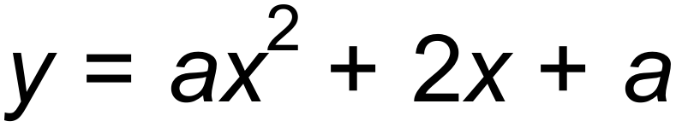.

**(a)** State the coordinates of the turning point of the graph of  in terms of a.

(2 marks)

**(b)** For which values of a does the graph of  have two x-intercepts? (2 marks)

**Question 12 (5 marks)**

**(a)** Shade the following region on the Venn diagram below: 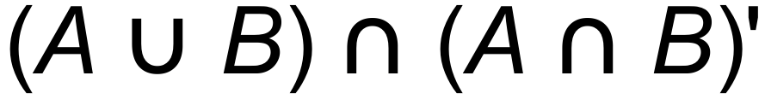 (1 mark)

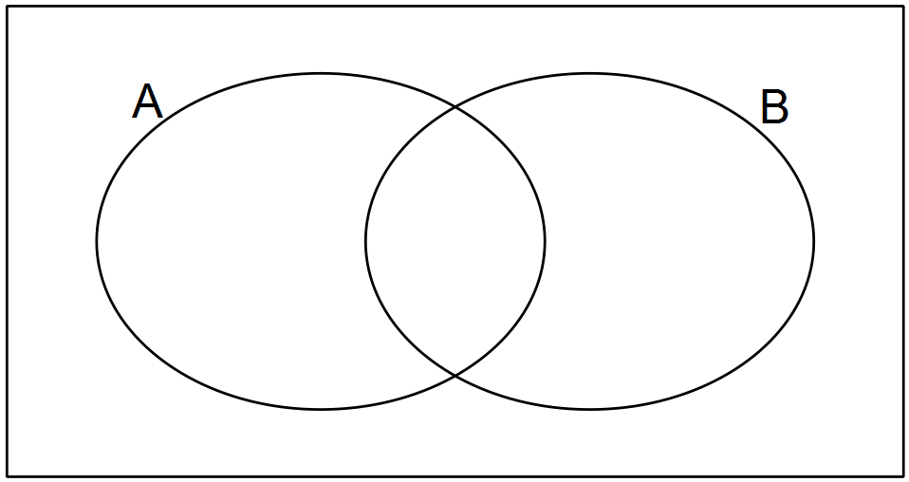

**(b)** The probability that a randomly chosen Maths student will pass Specialist is 0.7. The probability that he/she will pass Methods is 0.8 and the probability that he/she passes

both is 0.6. Determine the probability that the student:

(i) passes neither subject. (1 mark)

(ii) passes only Methods. (1 mark)

(iii) does not pass Specialist. (1 mark)

(iv) passes at least one of the subjects. (1 mark)

**Question 13 (5 marks)**

The instantaneous rate with which the cost (C) in cents of a certain share on the Australian Stock Exchange changes with respect to time, *t* (weeks), is modelled by 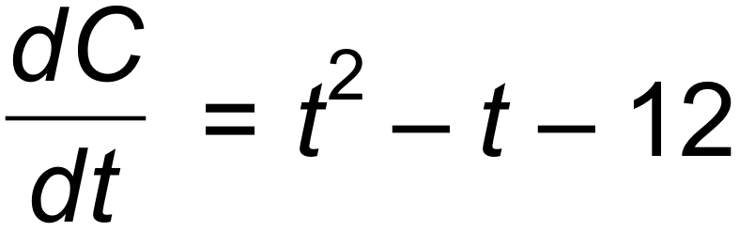 for the period

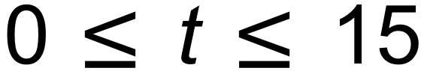. The initial cost of the share was 105 cents.

**(a)** Determine the cost of the share during the second week, when 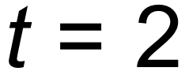. (2 marks)

**(b)** State the minimum cost for this particular share and when did this occur? (2 marks)

**(c)** During which week does the cost of the share exceed its initial cost for the first time?

(1 mark)

**Question 14 (5 marks)**

The distance to the horizon (d) which can be observed is directly proportional to the square root of the height of the observer (h) above sea level such that 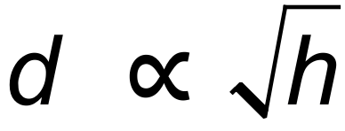.

A person, standing at sea level, whose height is 1.7 m, can observe approximately 4665 m out to sea.

**(a)** If Mr Vincent, whose height is 1.76 m, climbs to the top of Reabold Hill which is 85 m above sea level, how far, to the nearest kilometre, would he be able to see? (3 marks)

**(b)** Calculate the percentage change in d when h is reduced by 20%. (2 marks)

**Question 15 (6 marks)**

**(a)** State the recursive rule for the following sequences:

**(i)** 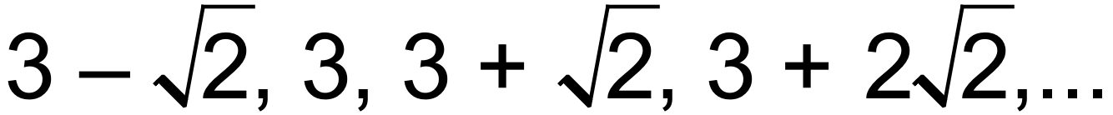 (2 marks)

**(ii)** 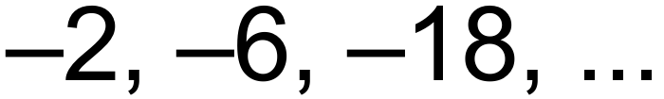  (2 marks)

**(b)** If an arithmetic sequence has a first term of 17 and a common difference of 3, find the

25th term. (2 marks)

**Question 16 (9 marks)**

**(a)** Consider 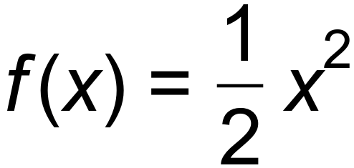 where *x* = 3. Find 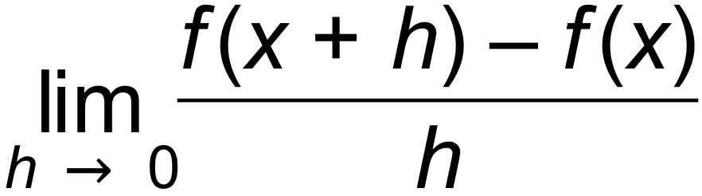 by completing the table below.

(3 marks)

|  |  |
| --- | --- |
| *h →* 0 | Limit = |
| 0.1 |  |
| 0.01 |  |
| 0.0001 |  |
| 0.000001 |  |

**(b)** Evaluate the following limit 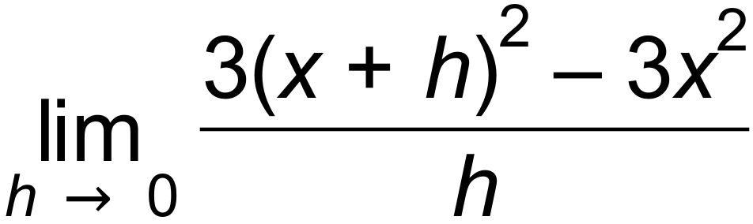.

(Hint: Identify the function being differentiated.) (2 marks)

**(c)** The function 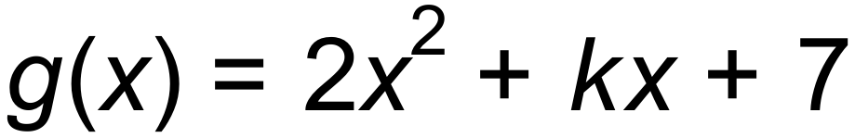 has a stationary point at 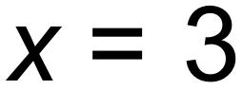. Find the value of *.*

(2 marks)

**(d)** If the gradient of the tangent at a point 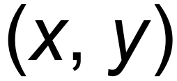 on a curve is given by 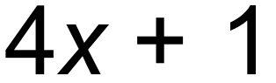 and the curve passes through (1, 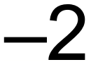 ), find the equation of the curve. (2 marks)

**Question 17 (8 marks)**

**(a)** Evaluate the following and leave your solution in standard form (scientific notation).

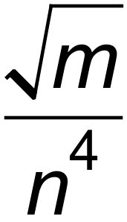 if 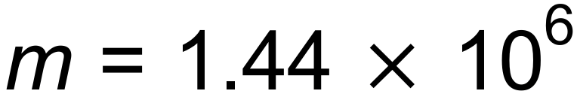 and 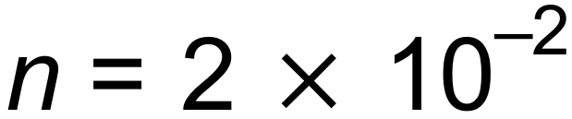 (3 marks)

**(b)** The number of bacteria, *P*, in a culture increases with time, in hours, according to the equation *P* =  *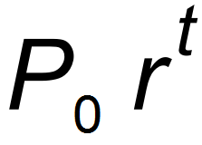.* The initial number of bacteria in the culture was 1200 and six hours later there were 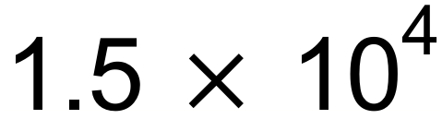 bacteria.

**(i)** Determine the values of *P0* and *r.* (2 marks)

**(ii)** How many bacteria would there be after 12 hours? (1 mark)

**(iii)** Determine, to the nearest minute, when the number of bacteria will reach 1 000 000. (2 marks)

**Question 18 (6 marks)**

**(a)** Sketch a graph with the following features on the axes below: (3 marks)

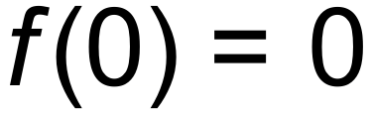 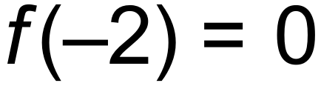

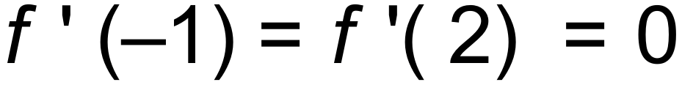 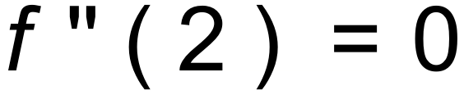

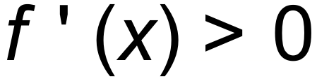 for 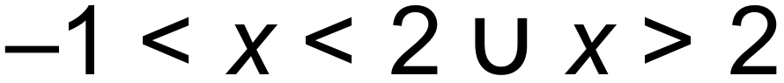

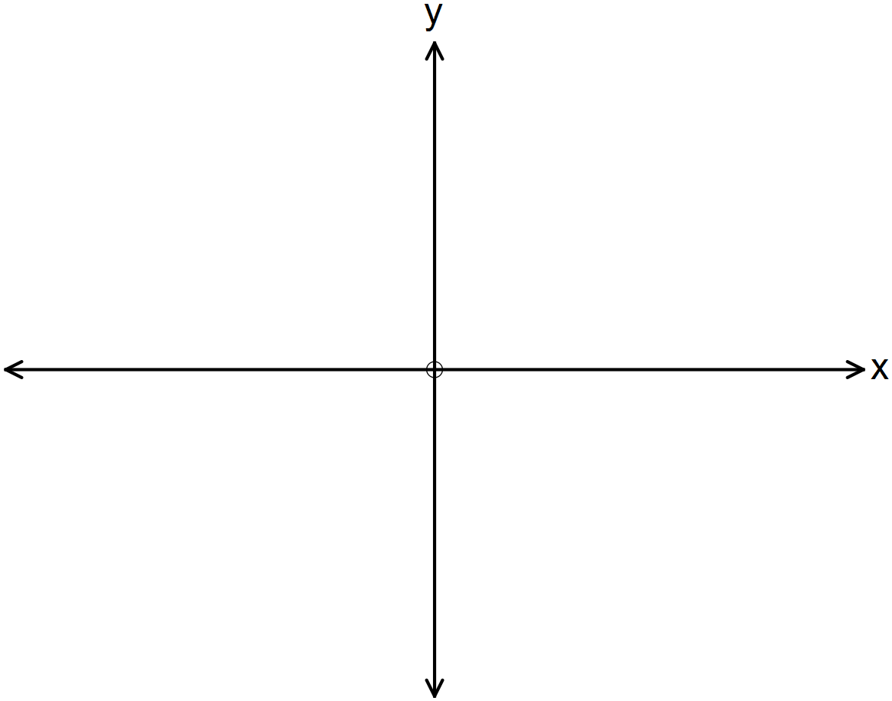

**(b)** Match the displacement –time graphs to their velocity-time graphs and complete the table below. (3 marks)

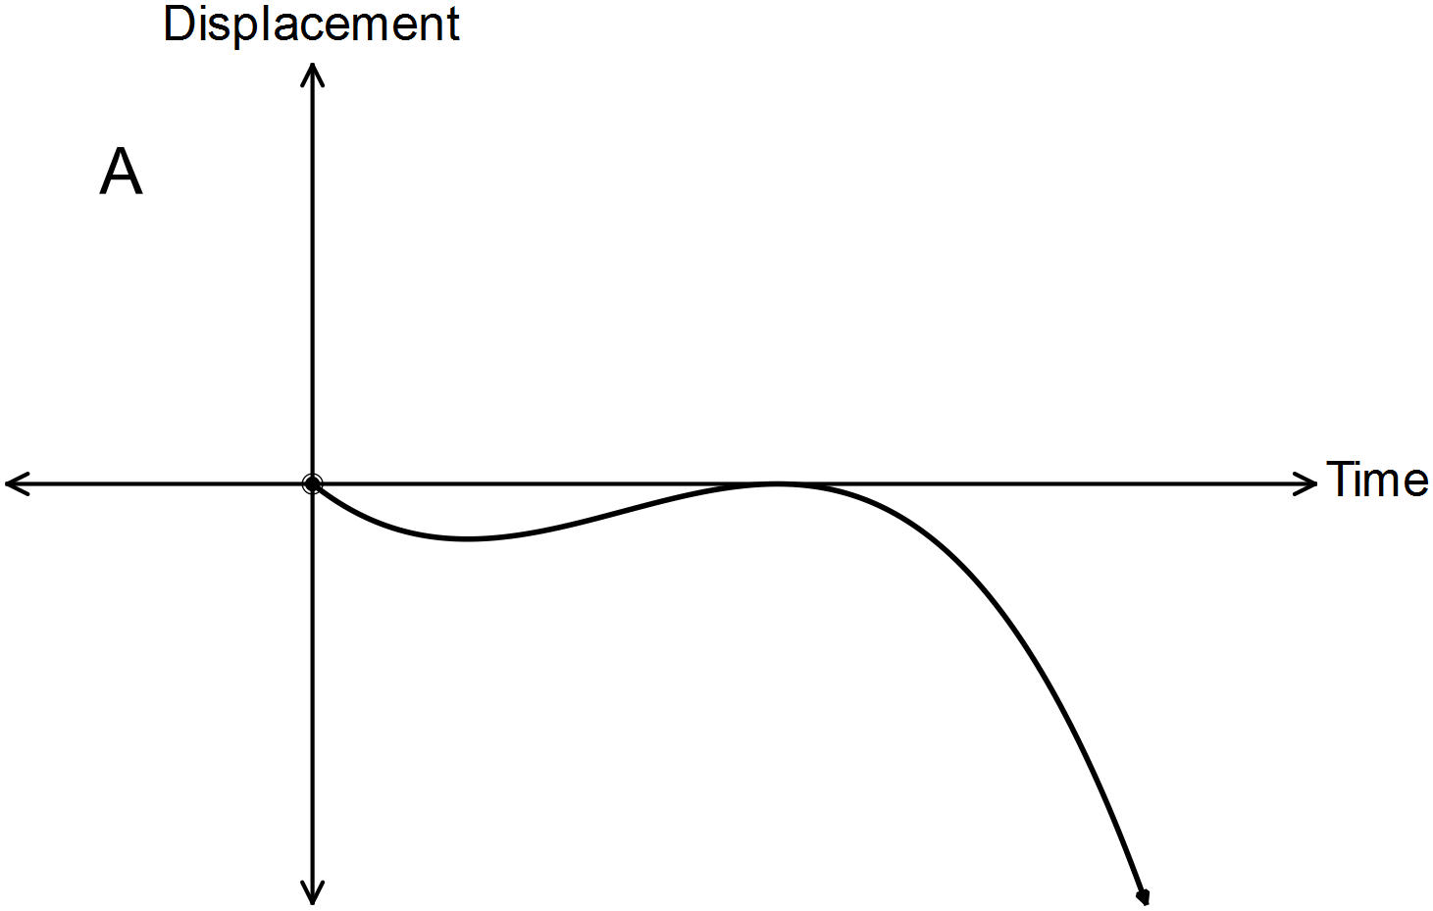

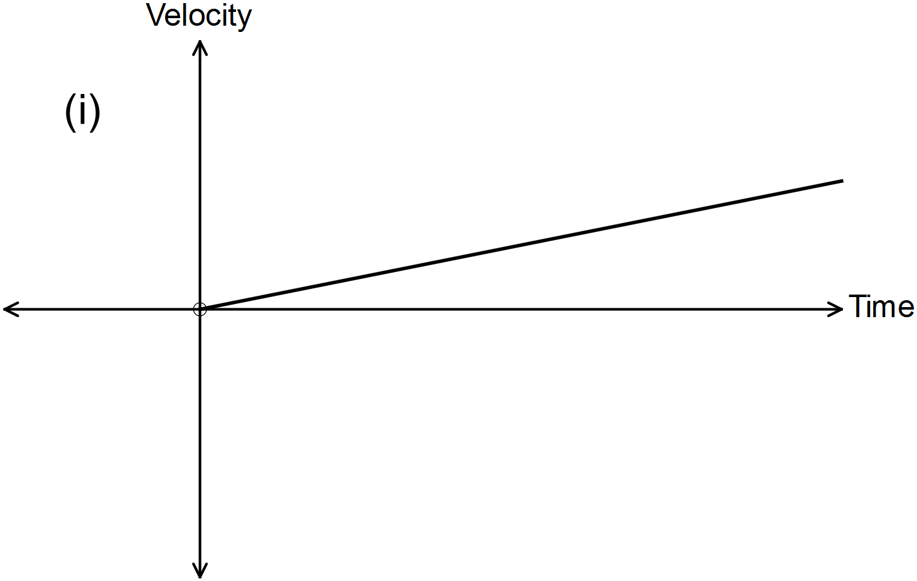

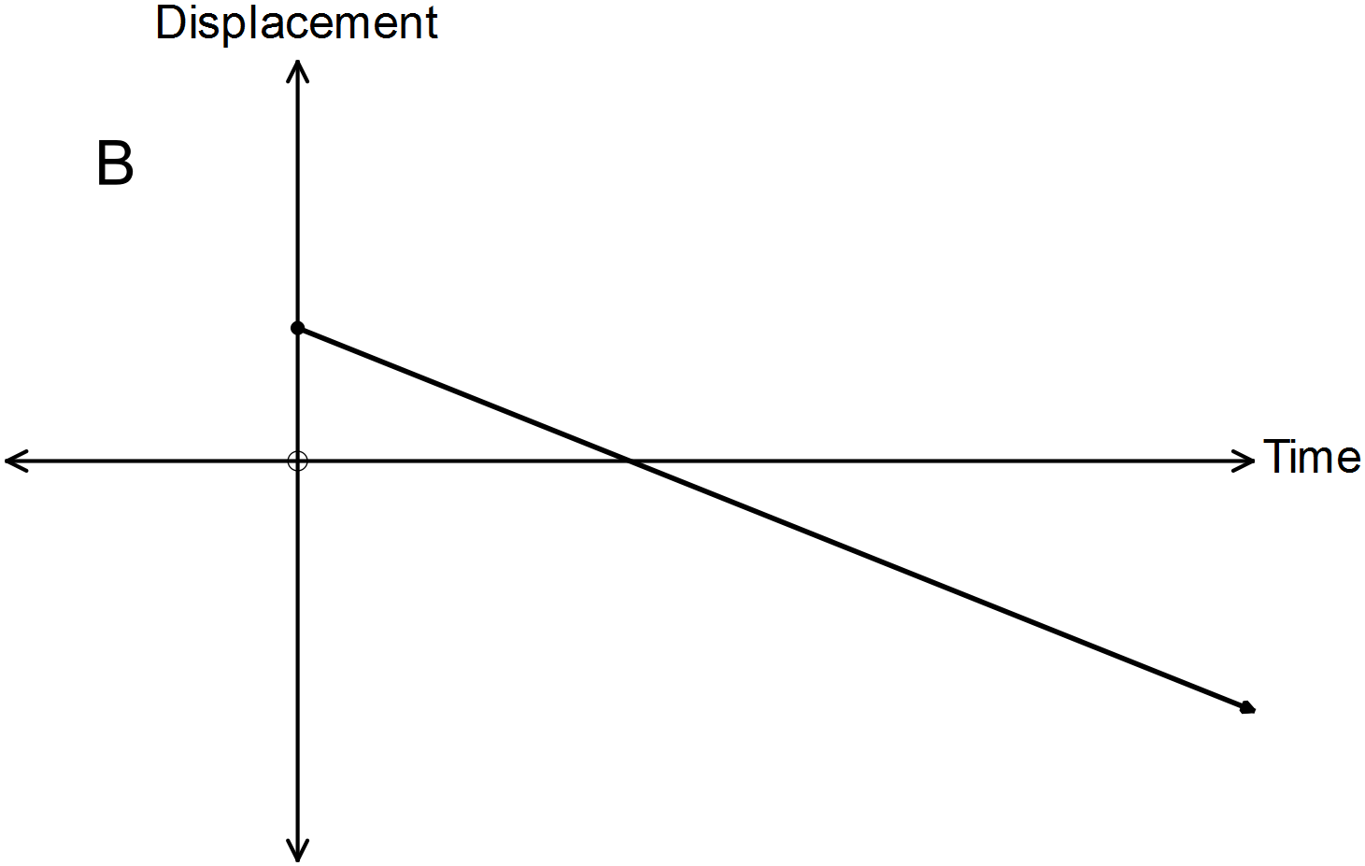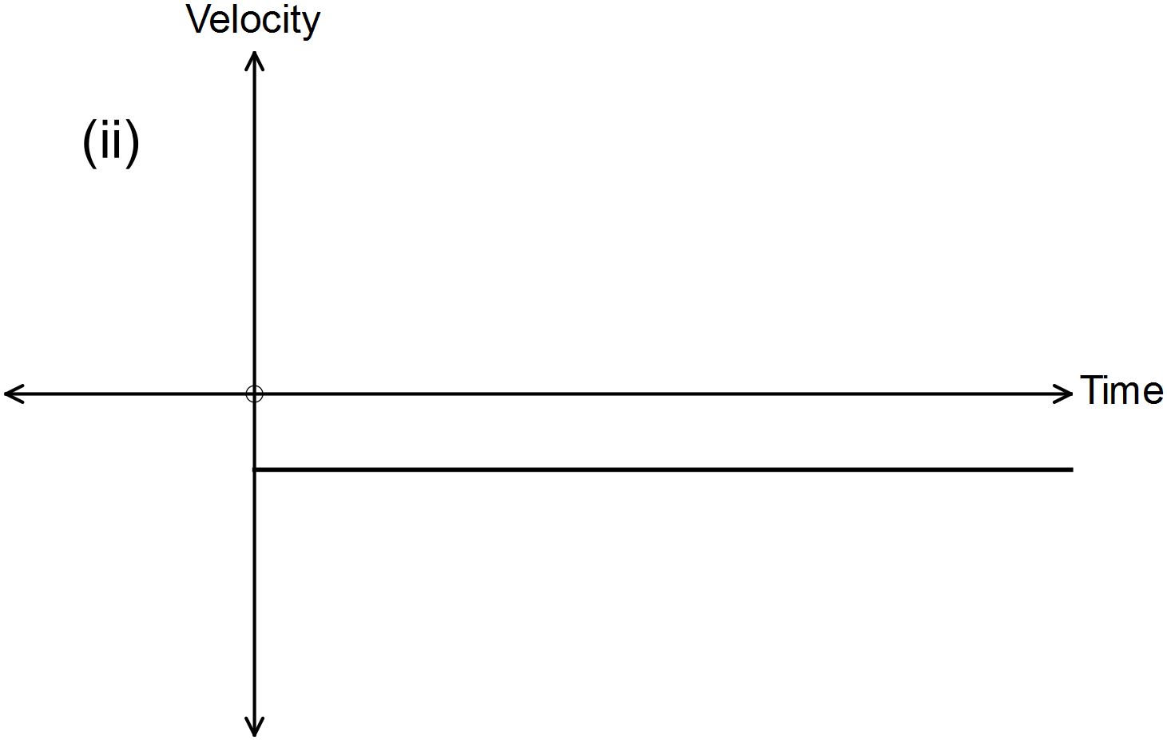

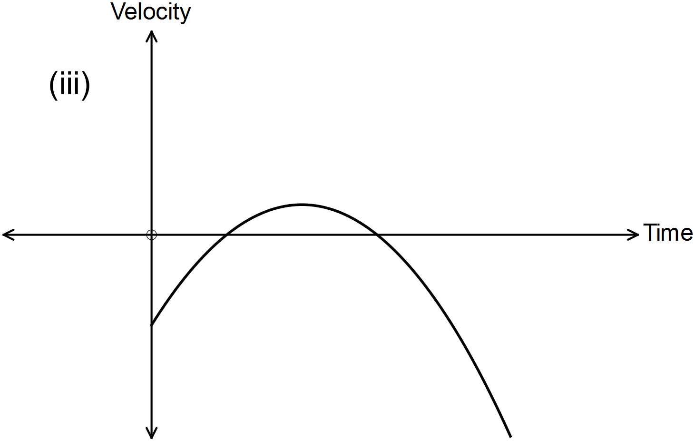

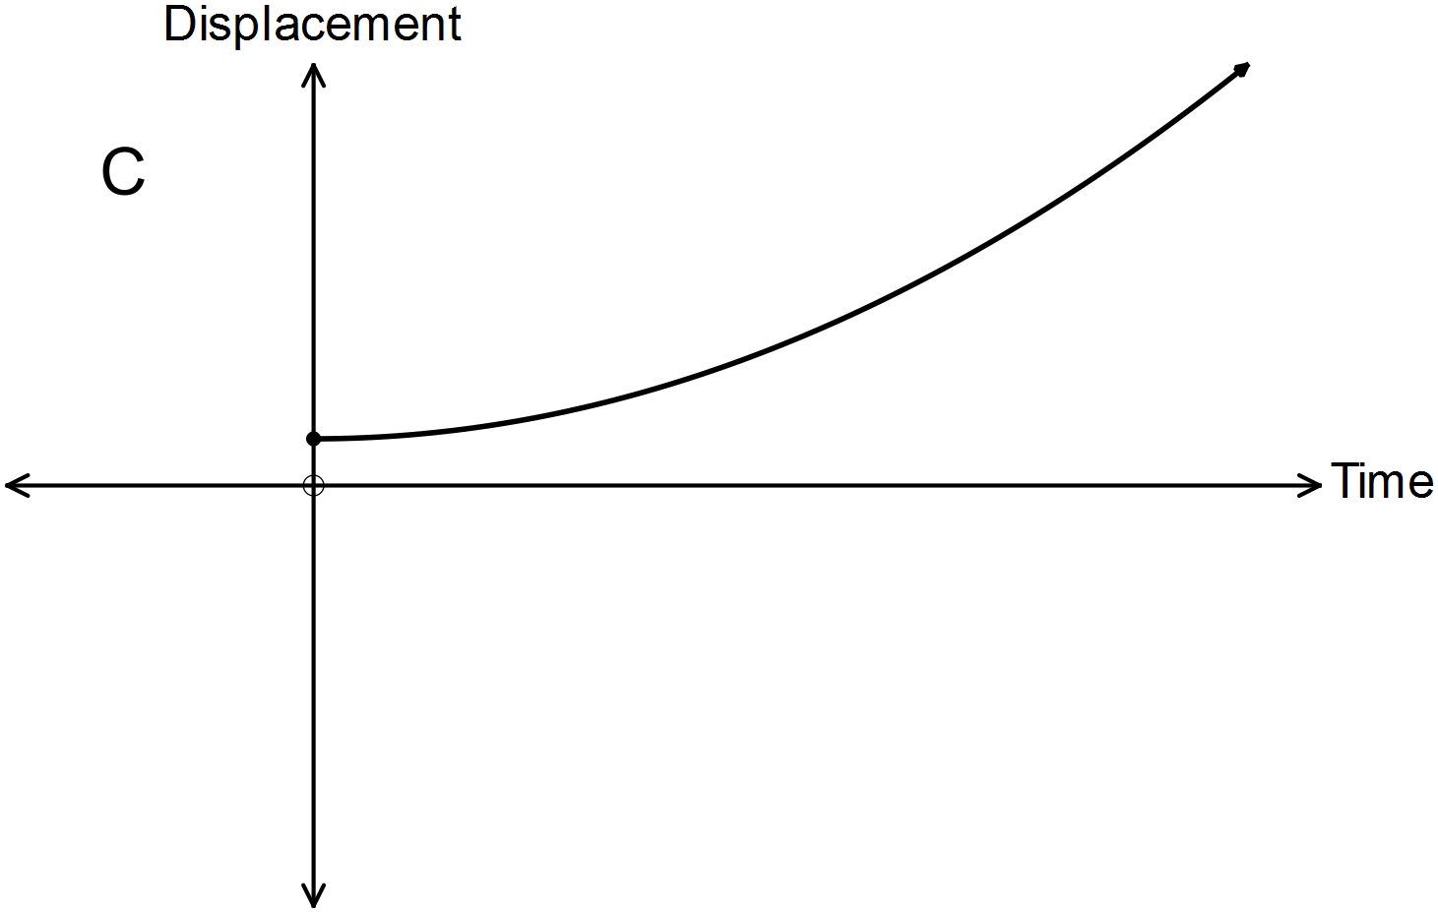

|  |  |  |
| --- | --- | --- |
| A | B | C |
|  |  |  |

**Question 19 (10 marks)**

**(a)** An outdoor movie theatre in Perth arranges its seats so that there are 26 seats in row A, 28 seats in row B, 30 seats in row C and so on.

(i) How many seats in row M? (2 marks)

(ii) Which row has 70 seats? (1 mark)

(ii) The final row is row X. How many seats are in the outdoor theatre? (1 mark)

**(b)** The sum of the first 10 terms in an arithmetic sequence is 205 and the sum of the first 20 terms is 710. Determine the sum of the first 30 terms. (3 marks)

**(c)** Evaluate the arithmetic series 254 + 251 + 248 +… + 176. (3 marks)

**Question 20 (6 marks)**

A rectangular pool has the following dimensions (in metres): the length is 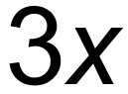, the width is 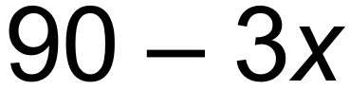 and the depth is 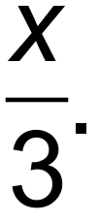

**(a)** Show that the volume is given by 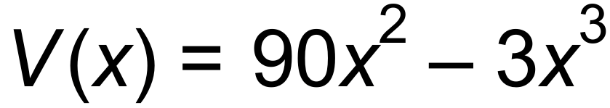. (2 marks)

**(b)** Use calculus methods to determine the maximum volume of the pool and the dimensions

of the pool to achieve this maximum. (4 marks)

**Question 21 (13 marks)**

**(a)** Consider the sequence A*n* = 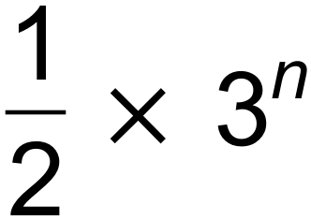.

**(i)** State the first 3 terms of the sequence. (1 mark)

**(ii)** State its recursive formula. (2 marks)

**(iii)** Find the sum of the first 25 terms to four significant figures. (2 marks)

**(b)** The number of people using a Health App on their mobile phones doubles every month. At the beginning of the first month there were 6 users.

**(i)** How many users were there after 1 year (i.e. at the end of month 12)? (2 marks)

**(ii)** After how long would there be 1 million users? (2 marks)

**(iii)** Each user buys the app for $1.15. During which month would the revenue from selling the app exceed $6 million? (2 marks)

**(c)** The recurring decimal 0.454545… can be written as the geometric progression

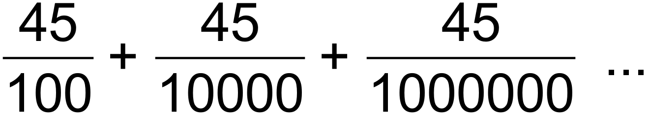 .

Write 0.454545… as a common fraction by finding the sum of the progression to infinity.

(2 marks)

**Question 22 (9 marks)**

A jet ski moves in a straight line past a buoy so that its displacement from the buoy is modelled by the function 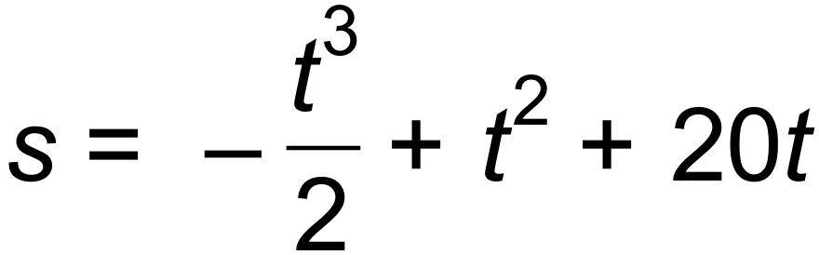, where s is measured in metres and t is in seconds for 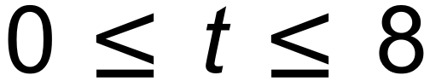.

**(a)** How far does the jet ski move from the buoy in the first 3 seconds? (1 mark)

**(b)** Determine the average velocity of the jet ski during the first 3 seconds. (1 mark)

**(c)** Determine the instantaneous velocity of the jet ski at t = 2 seconds. (2 marks)

**(d)** Use Calculus methods to find the maximum displacement of the jet ski from the buoy and when this occurred. (3 marks)

**(e)** Determine the total distance the jet ski moved during the 8 seconds. (2 marks)

**Question 23 (9 marks)**

**(a)** Determine the coordinates of the point where the tangent to the curve of the function given by 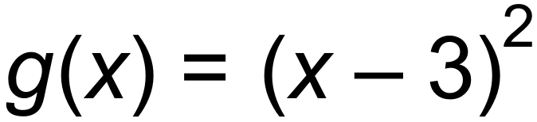 is perpendicular to the line given by 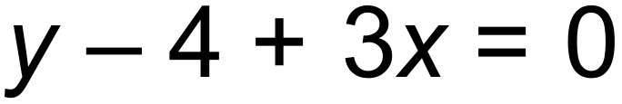. (3 marks)

**(b)** The function 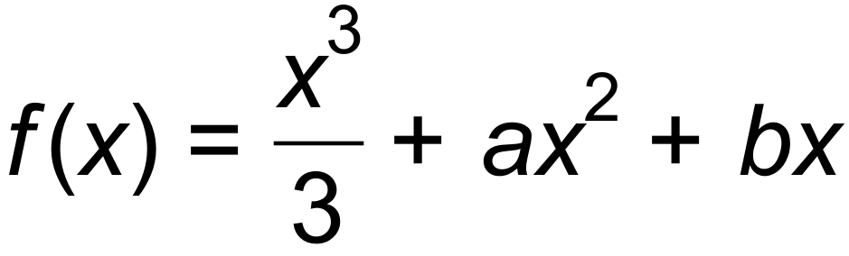 has a local turning point at 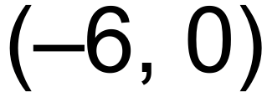.

**(i)** Show that the values of  and b are 4 and 12 respectively. (3 marks)

**(ii)** Determine the coordinates of the other turning point and state its nature. (3 marks)

**End of questions**

**Additional working space**

Question number(s): ……………………

**Additional working space**

Question number(s): ……………………